Problem Description:

The nature of this project is to understand the HMM and apply HMM to handwriting recognition.

There are a few HMM types and quite a lot of variations, so before get deep into HMM, we need figure out the proper HMM model to use. From system point of view, characters input by the user are transformed into a track of dots, which are discrete. So we should concentrate on discrete HMM and find out the conditions to apply this model.

First of all, HMM contains hidden states and observations. In handwriting, obviously, the tracks of the strokes will be the observable objects. In terms of states, there are a few options. We need find out the best option for us.

Secondly, we need find out the basic five elements of HMM in our project.
- The number of states in the model
- The number of distinct observation symbols per state
- The state transition probability distribution
- The observation symbol probability distribution in each state
- The initial state distribution

Thirdly, we need train the models which are going to be used for recognition purpose. Training stage will contain initial training and optimisation. In the training stage, one important issue we must address is training set selection. In this project, due to the constraint of time, we can not train too many data, so selecting the delegates of characters and strategy for expansion are significant matter to this project.

Lastly, recognition of models.

Training set selection:

The training data we select should contain most common used Chinese character strokes or they represent some particular issues. The picture below shows the most common used Chinese character strokes.

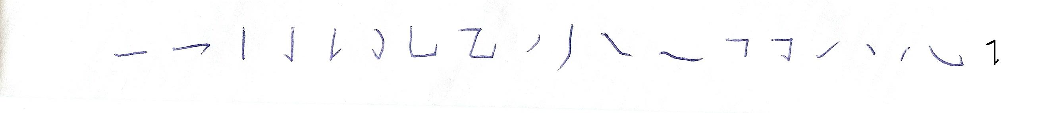
Common used Chinese character strokes

To address common strokes, we choose the following training data:
“认，一，买，十，于，顷，手，七，九，八，川，边，敢，力，冲，心”

Some of the Chinese character share exactly same strokes, but differ on the length of strokes, for instance, “士” and “土”. Sometimes the situation is even worse, for instance “田，由，甲，申，电”. So these characters are added into the training set as well.

The entire training set so far is “认，一，买，十，于，顷，手，七，九，八，川，边，敢，力，冲，心, 田，由，甲，申，电”.

Chinese language has more than more than 50,000 characters, and more than 1,000 common used characters. But no matter how complicated the characters are, they almost always composed by the strokes we listed above. Since the delegates we selected have already contained all of these strokes, a well trained system using the delegate training set should be able to cope with the expansion data set.

